TARS 2026 HF CONTESTS UPDATE – MARCH

RSGB 80M CC DATA
M0TQR BRIAN – 55 M8EVM EDDIE – 38
RSGB 80M CC CW
G6GLP TONY - 18
RSGB COMMONWEALTH CW
G6GLP TONY - 26
RSGB FT4 CONTEST
M0TQR BRIAN - 28
RSGB 80M CC SSB
G6GLP TONY – 103 M7DPA ALEX – 62 M0LAI PETER – 59 G4VUD JOHN – 57
M0HHG GARY – 57 M0TQR BRIAN – 46 G4VTO PETER – 27

OTHER CONTEST RESULTS
M0TQR BRIAN – ARRL INT DX SSB -54qso – 30mults – 4680pts
M0TQR BRIAN – EA PSK63 CONTEST – 71qso – 59mults - 8142pts
M0TQR BRIAN – CQ WPX SSB – 172 qso – 139mults – 40032 pts
M0HHG GARY – CQ WPX SSB – 215qso – 173mults – 62972 pts
G6GLP TONY – CQ WPX SSB – 30qso - ? mults - ? pts

FORTHCOMING RSGB CONTESTS APRIL 2026
RSGB FT4 INT ACTIVITY DAY Sat 11th April 1200utc – Sun 12th April 1200utc
RSGB 80M CC CW Mon 13th April 1900hrs - 2030hrs
RSGB 80M CC SSB Wed 22nd April 1900hrs – 2030hrs
RSGB UKEI DX CW CONTEST Sat 25th April 1200hrs – Sun 26th April 1200hrs
RSGB FT4 CONTEST Mon 27th 1900hrs – 2100hrs
RSGB 80M CC DATA Thurs 30th April 1900 - 2030hrs

OTHER CONTESTS APRIL 2026
SP DX CONTEST SSB/CW Sat 4th April 1500utc Sun 5th April 1500utc
OK/OM DX CONTEST SSB Sat 11th April 1200utc Sun 12th April 1159utc
CQMM DX CONTEST CW Sat 18th April 0900utc Sun 19th April 2359utc
DUTCH PACC DIGI CONTEST Sat 18th April 0700utc – 1900utc
SP DX RTTY CONTEST Sat 25th April 1200utc Sun 26th April 1200utc
UK/EI DX CW CONTEST Sat 25th April 1200utc Sun 26th April 1200utc

Well Presentation Night is over and a good night had by all.
Congratulations to all the members that won certificates and cups this year and remember you have to be in it to win it !

As you may know myself M8EVM & Alex M7DPA Was working G2EC for the royal signals contest team in Dorset for the CQ WW WPX CONTEST ,
We arrived friday lunchtime and after some .familiarisation at midnight we was on .
There were 7 in the team with 4 station setups so we could have 3 on break. We ran the whole 48hrs non stop, the station was 2 icom 7610 elecraft k4 and icom 7760, these had 3 acom 1000 amps and a spe expert amp , 2 towers 1 hex beam and 1 beam and for 40m a 4 square and 80m vertical.
We managed 2,518 qso and with mults a total of 5,746,724 points , hopefully this will put us in 2nd place in uk after M6T.
Have a good easter and see you soon at the club hq.
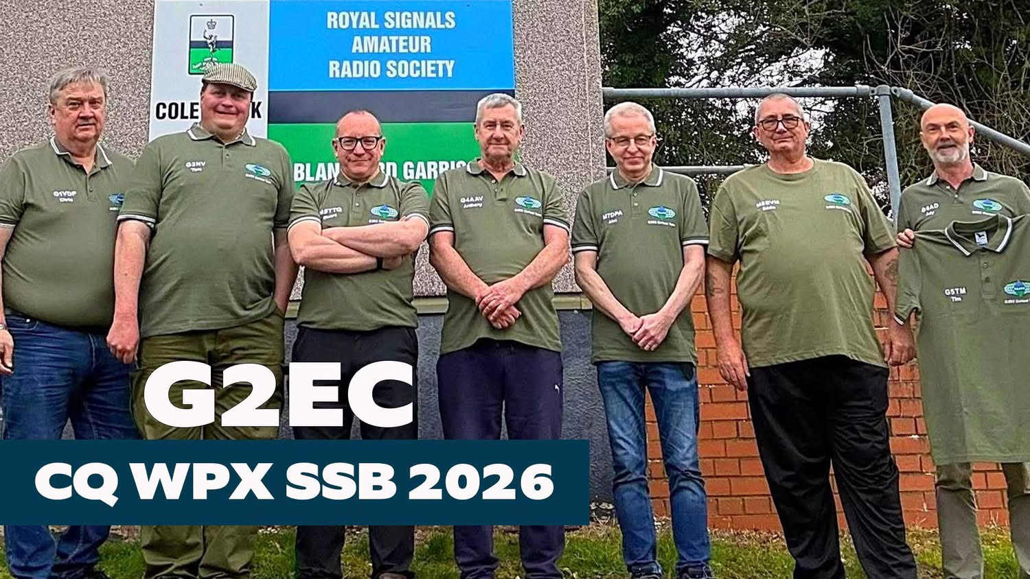
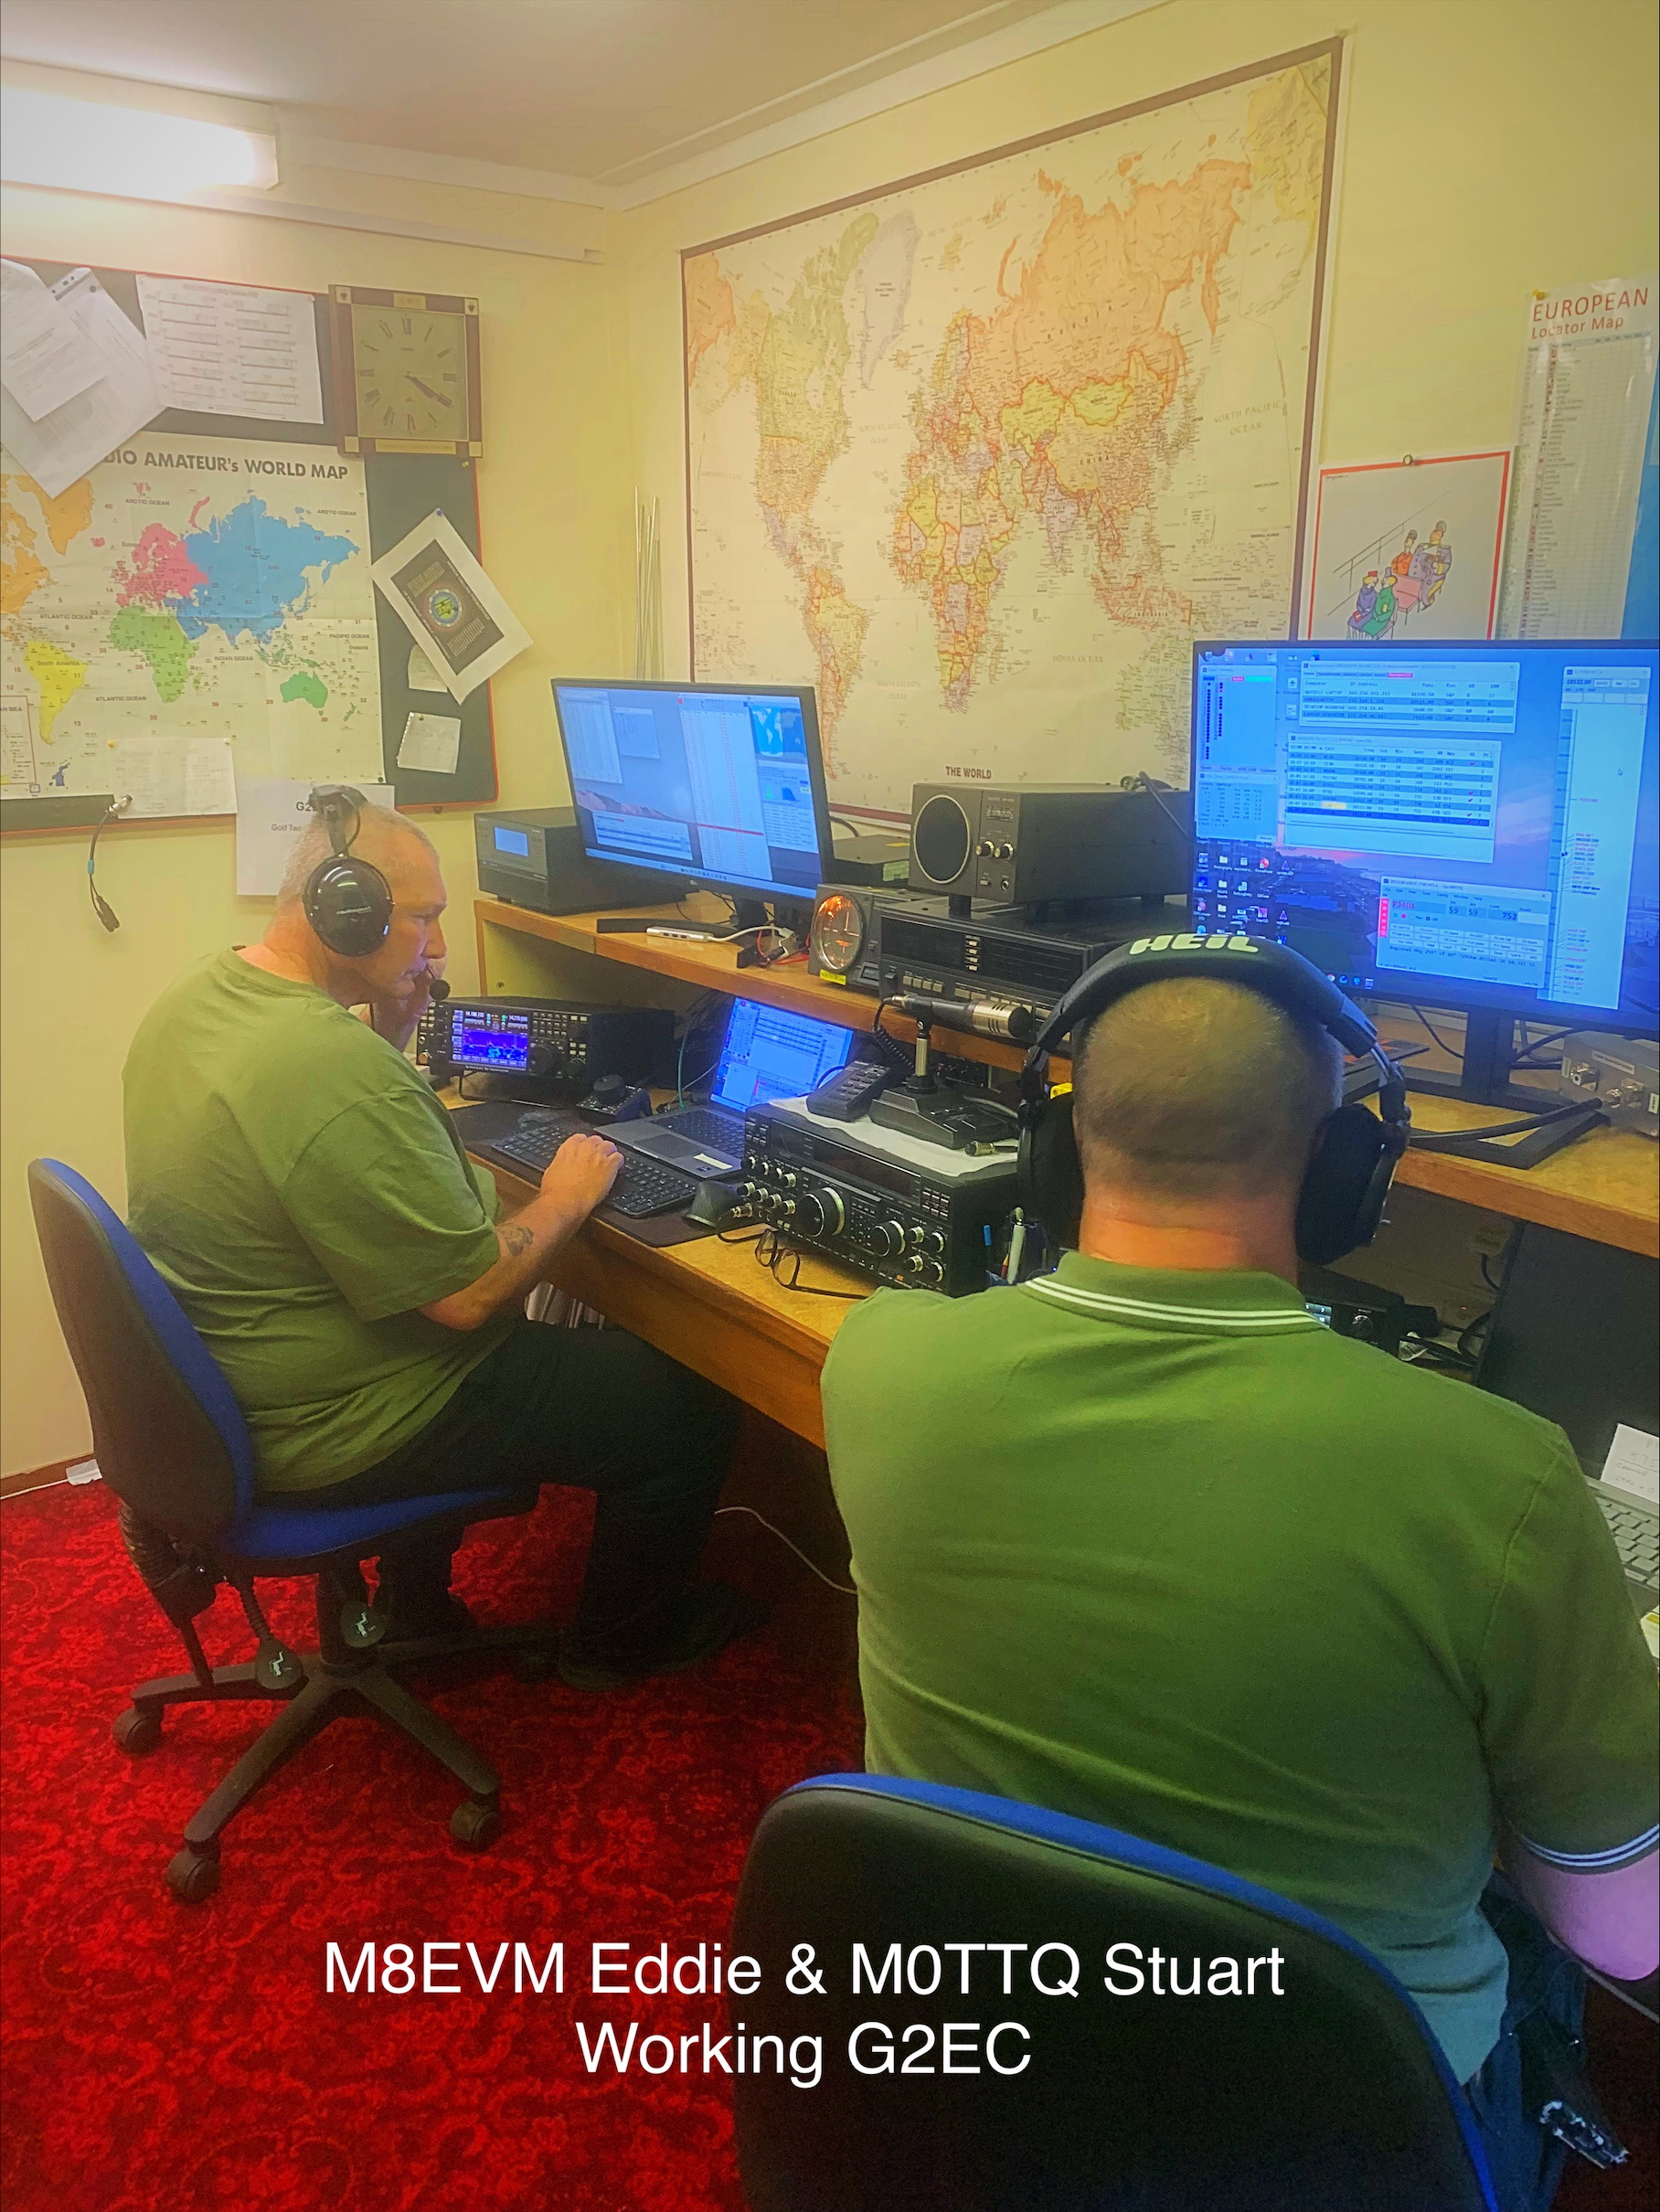

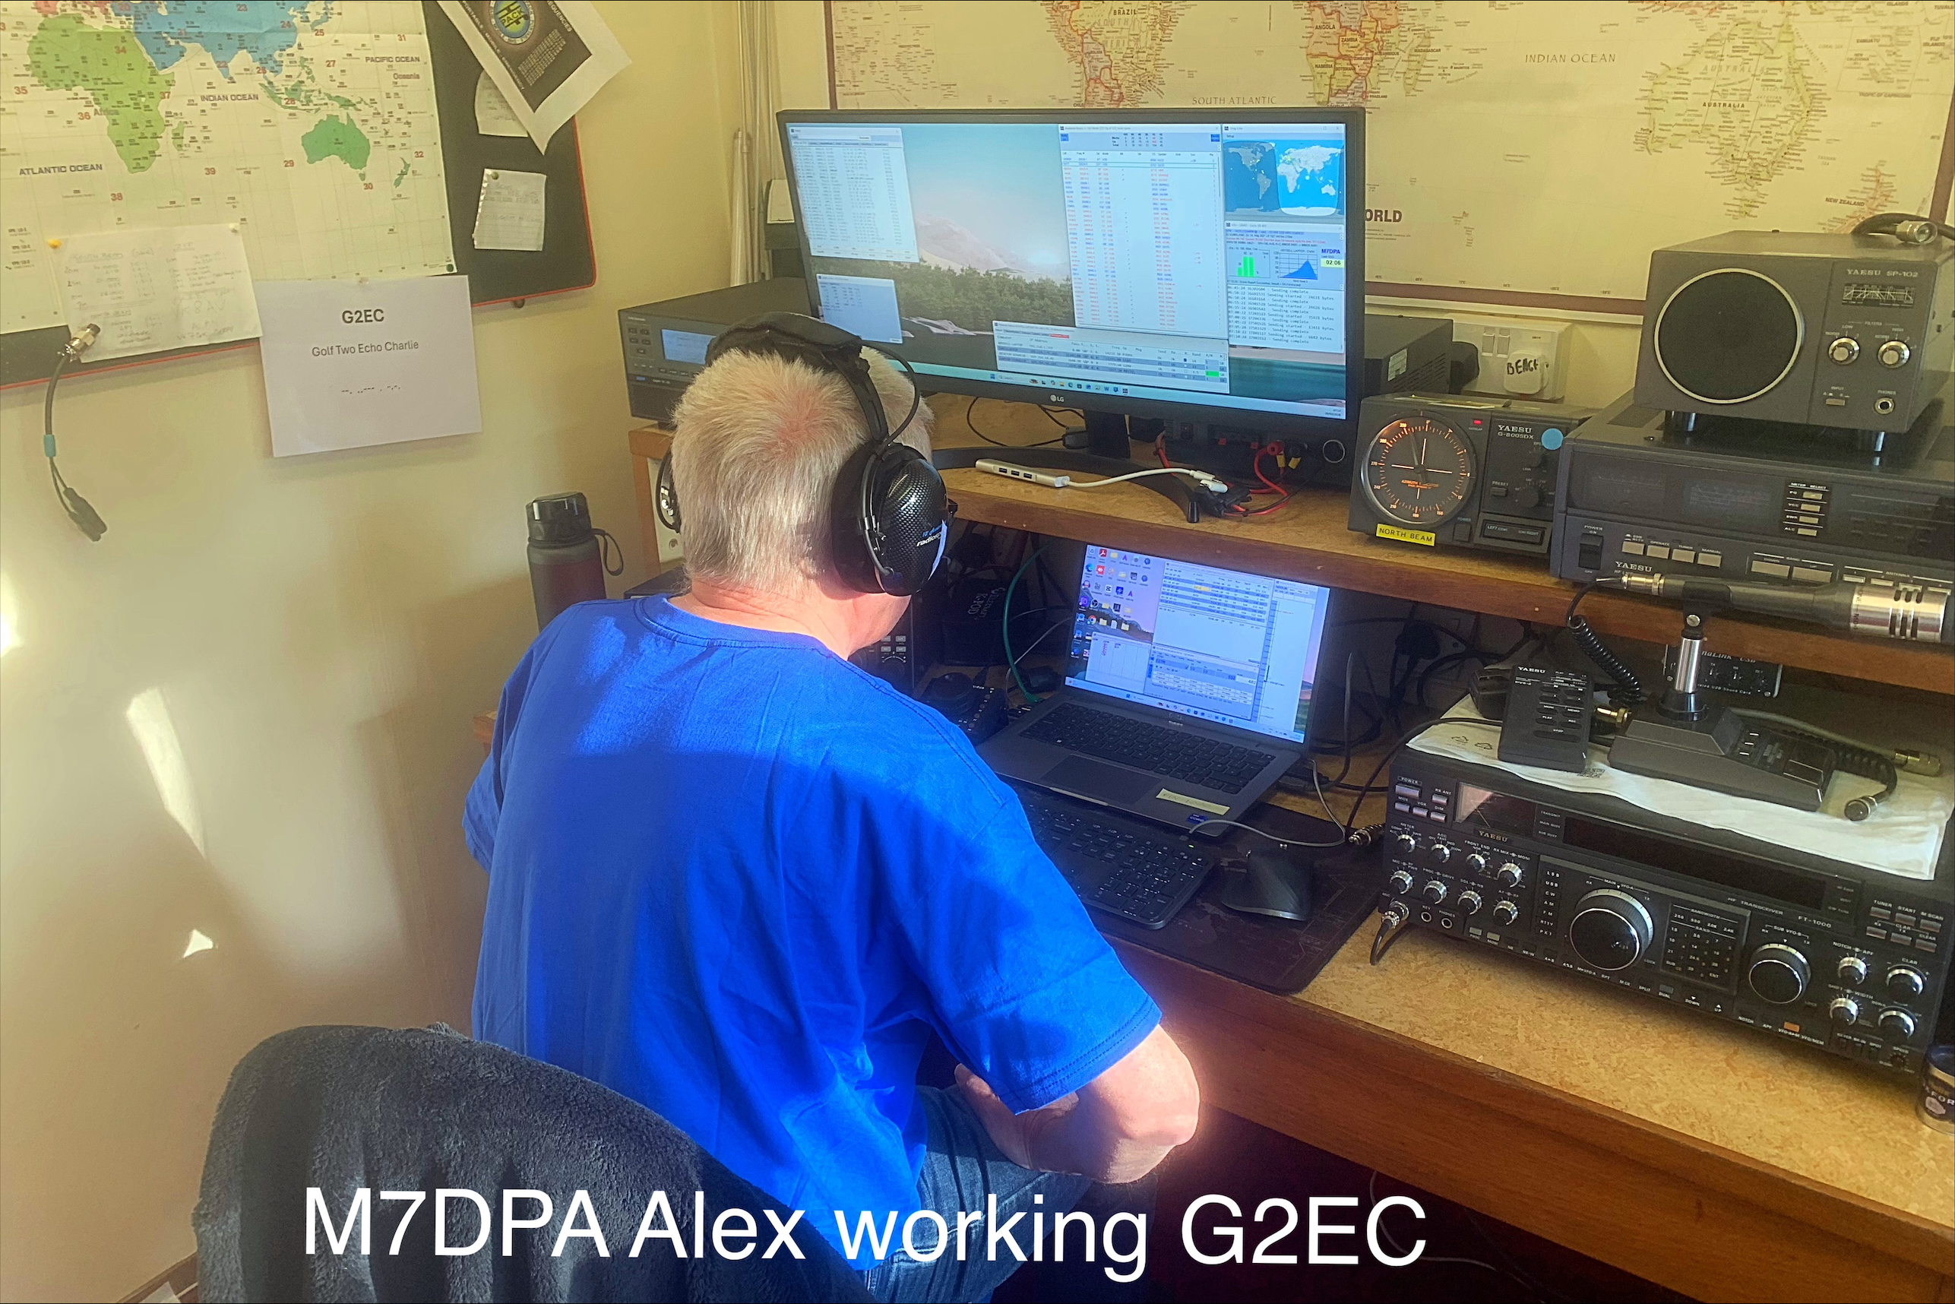

There are quite a few more contest in April, so suggest you have a look at WA7BNM web site for all your contest info, just click on the blue square on the far left of the contest & that will bring up all the that contest info, That’s it for this time,
Don’t forget to let me have your contest reports for end of April 2026 for the HF Report
73 & have fun Eddie M8EVM. Reports Sent To: 2e0evm@gmail.com

