Advice and Information for candidates and newly qualified Foundation Licence Holders

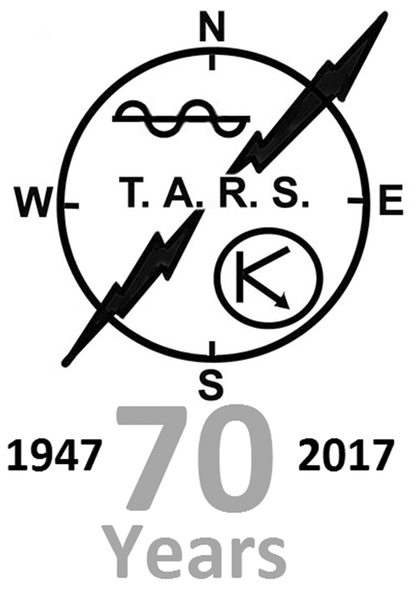

A generic guide – where to start.
(Ver. 0.2 pilot)
Tars Training Team
Written By Lin M0TCF

Foreword

Firstly, on behalf of the TARS Training Team (Trg Tm) and all the club members, congratulations on gaining your Foundation Licence. Now you can begin to reap the rewards of all the work you’ve put in over the last few weeks.

If you’ve followed the advice of the training team, then by now you will already have acquired a radio for yourself and either downloaded the relevant file with all the local repeaters etc or laboriously programmed them in by hand (good luck with that!). Either way, once it’s done you can get out there join the various local nets and begin to explore both the capabilities and limitations of such a device.

You should be confident operating, but don’t worry if you’re not – part of the reason we put this handy guide together was to back up the training that is/was part of your Foundation course.

From your training, you’ll know what the limitation of your licence are – power output, type of emissions, frequencies etc, most new operators are keen to get an HF station set up and get talking to the world – after all, isn’t that exactly what amateur radio is all about? Well, yes, it is and a whole lot more!

Probably the best way to regard this guide is as a handy reference, written as the first stop when a question arises. The club members who have contributed to this booklet have many years of hard earned experience behind them and wish to pass it on to you, in the hopes it will be both useful and might even save you a few pounds or more!

Acknowledgements:

All information & pictures used are taken from the public domain, the owners have expressed their rights. No part of this publication may be altered, modified, republished without the express permission of the author.
Index

Equipment

New or second-hand?
Your first transceiver.
The power supply
VSWR meters
VHF Antennas
Safety Concerns
Plugs and feeder lines (Coax).

Operating Your Station

UK Call signs
Log Books & Logging
Signal Reports
NATO Phonetic Alphabet
Q Codes and other terminology
Making your first contact

Retailers, Books & Further Useful Information

People
Radio
Books
Magazines
Internet
Clubs

Annexes:

A. Explanation of CTCSS
B. Examples of Band Plans (2m & 6m)
C. Frequency Conversion Chart
D. South West Repeater List
E. DX Code of Conduct
F. TARS Training Application Form

Equipment

To buy new or second-hand? Always the same question and one frequently put to members of the training team. The answer(s) are varied, but always measured and it really does come down in real terms to how deep your pockets are! Putting that thought aside for a minute, you have to ask yourself just what your aspirations are and balance those against what you can realistically hope to achieve.

Before you splash those hard-earned pounds burning a hole in your pocket heed our advice please:

- Don’t buy your first (or any) radio ‘blind’ over the internet – it’s far too easy to get burned! (Unless it’s a £20 ‘Feng’ from Amazon etc). Dealers excepted, but with caveats!

- Avoid ‘modified’ radios, normally listed ‘wide banded’ etc. Mainly for the Citizens Band frequencies, which is outside their design criteria and as a consequence equipment just ends up being damaged beyond use.

- There is absolutely no need to buy the latest all singing, all dancing rig when a far simpler item will suffice – useful gear will always have an intrinsic value! You will spend more time getting lost in menus and settings than actually using it!

- If you go to view a piece of equipment, take a knowledgeable friend along to ask awkward questions.

- If buying a radio, make sure you get the power lead and microphone – preferably the original one and if you don’t, adjust the price accordingly! Any extras you get like programming leads etc are a bonus.

- Have the seller demonstrate that it works to your satisfaction and if possible, make a contact using the radio.

- If you’re buying second-hand items from a dealer ask about warranty – don’t expect much, but if you don’t ask, you don’t get!

- Don’t discount older pieces of equipment, just because it doesn’t have ‘digital sound processing’ or a ‘software defined’ front end doesn’t mean it isn’t worth considering – many a good tune has been played on an old fiddle!

- Keep in mind that your transceiver (or transmitter & receiver should you buy vintage gear) is only one part of your station and you will need to purchase other ancillary equipment as well.

- When it comes to second-hand equipment, the immortal ‘caveat emptor’ applies, it’s down to you to decide if what you are looking at is what you want!

- Like every facet of life, sadly there is always somebody willing to take advantage of a newcomer! Be sensible; if something looks too good to be true, then it probably is! If you're offered something cut price (and before parting with your cash), ask around the club and the training team; a genuine seller won’t mind in the slightest.

On a far more positive note, best place to start asking about gear for sale is at the club! Members may well have items sitting around in their shacks no longer being used that they may be willing to pass on to a new licence holder for a fraction of its original cost. Besides, no club member wants to get a reputation for passing on ‘duff’ equipment!

You can also find a whole myriad of equipment for sale in magazines, on other club websites, the local press and from equipment retailers (see last chapter for listings).

One of the most interesting ways to source items is from a radio rally; traders and retailers from around the region gather often, in different locations around the region. Notification of what’s going on locally is normally given at club nights and there are national listings in various magazines including Radcom, the RSGB’s own journal. The same rules above, for buying any equipment, also apply at rallies – you have been warned!
Your First HF Transceiver

We could simply start here by listing some of our favourite pieces of equipment, ubiquitously known to all as ‘Rigs’. However, like most things in life, what’s ‘new’ today is tomorrows ‘old hat’ and newer models are being released on a fairly regular basis.

As mentioned previously, its entirely unnecessary to buy a hugely expensive rig, especially one with as many as 200 menus’, each with numerous other sub-menus and sub, sub menus as well! It’s a pointless exercise in frustration for the new operator!

Putting aside your budget, keep in mind that at today's prices (circa 2022) you are going to be spending approximately £500-£600 on a reasonably modest HF station. Two to three hundred pounds gains you a transceiver built within the last 10-15 years, add in the cost of a power supply (PSU) (another £100) and coax at £50-£100 depending on how much you need, an Antenna Matching Unit (AMU) – a totally feasible project or budget £50 - £100. Last but not least, an antenna of sorts, which really can be built for twenty quid!

Like a lot of car owners, radio operators tend to be very loyal to manufacturers and at times unreasonably so, which can quite unintentionally lead a new operator astray. Most of the periodicals carry reviews of new equipment and there are at least two published ‘Rig Guides’ listing the attributes and current values of second-hand radios – the training team probably have at least one copy of each for you to peruse; please remember to give it back!

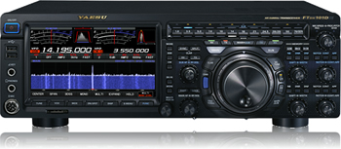

A Yaesu FTDX101D Lovely radio but not exactly a top choice for a new operator!

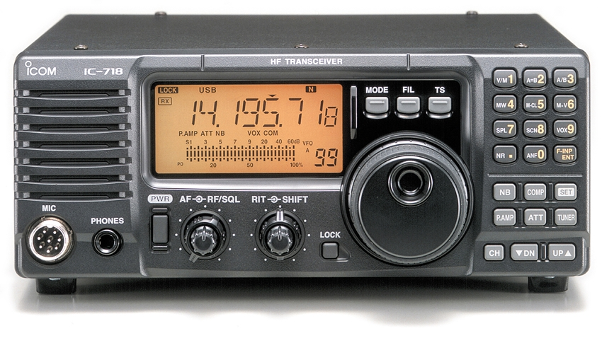

An Icom 718 – as operated by the TARS Training Team. Simple and easy to use with everything a new operator needs! A good all-rounder.

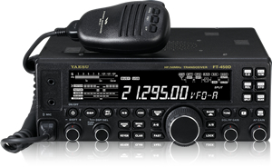
The Yaesu FT 450 – A firm favourite with an awful lot of people, available in various different models. Don’t pay extra for the AT model, unless you really want one!

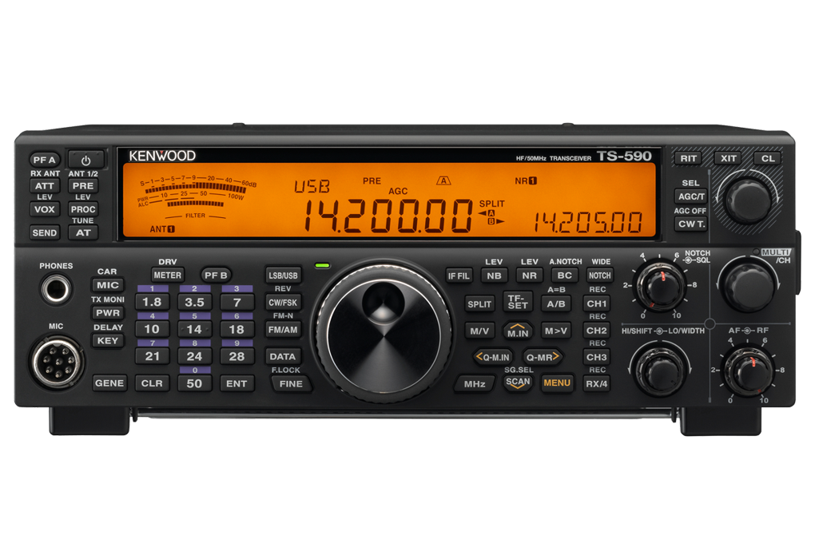
Kenwood TS590 – Another radio familiar to TARS Operators. Comparable to the FT450 but more expensive.

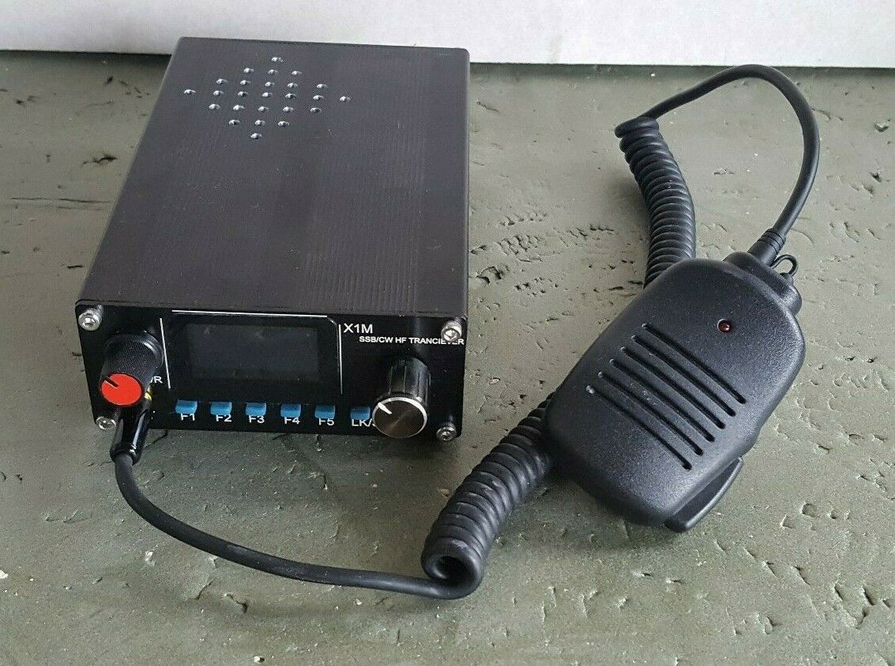
Don’t discount equipment coming in from China, some of it can be excellent value for money, but it can also be a nightmare if something goes wrong!
When it comes to choosing your first HF radio, whatever it is, take your time, ask fellow club members their experiences and importantly if anybody has a suitable radio for sale?
Your First VHF/UHF Transceiver

Got your ‘Baofeng’ yet??

Don’t laugh, regardless of how you come to view them eventually, these little radios have done a great deal to bring Amateur Radio within grasp of every bodies pocket!

Plenty of colleagues at TARS have run these handheld radio’s as a cheap and efficient mobile units, with the addition of a cost effective external mobile antenna and a combined speaker/microphone unit:
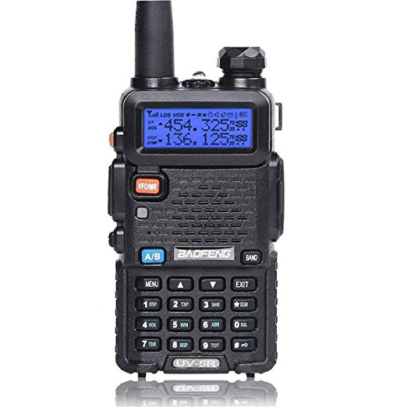
Available in a bewildering array of models, all with different names and from seemingly endless manufacturers. Broadly speaking they’re pretty much all the same, but do come with some proviso’s:

1. They are cheap, so build quality can be variable, but less so these days.

2. Use software and a cable to programme them, make sure you get the correct version.

3. An after-market antenna (¼ over 5/8 wave whip) will significantly improve reception and range.

4. Avoid high power versions – apart from eating batteries, having something which emits 50 times the amount of power that a mobile phone does right next to your head probably isn’t healthy (it’s your brain right…..)

Prices start from as little as £5 for an older second-hand one (although it has been known in the past for them to be given away free….). Twenty pounds gets you a newer model from the internet or Amazon etc. Don’t pay for software (use ‘Chirp’ which is free) and try and get the USB cable thrown in with the deal but having said that it’s only a five minute job to make one anyway!

Mobile Radios

Of course you may want something a little more exotic in your vehicle than a ‘Feng hand held’ (always keep on in the glovebox anyway), joining in a net on the way to a club night, chatting to a contact via a repeater or putting out a simplex call while driving can break up any journey – long or shot.

Just like HF Transceivers, the choice for VHF/UHF rigs is varied and can be as expensive (or cheap) as you like!

A lot of mobile radio’s today come as dual band as standard, it’s still entirely possible to buy single band radios but manufacturers seem to be following a trend.

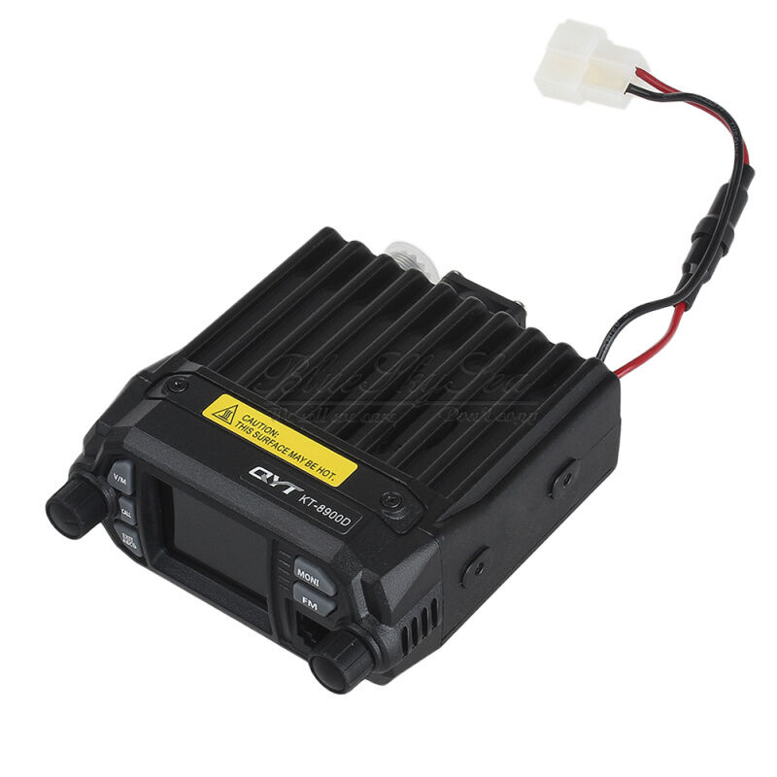
This QYT from China is an inexpensive modern dual band radio with everything a new operator needs onboard i.e. CTCSS, split operation and lots of unnecessary menu choices too!

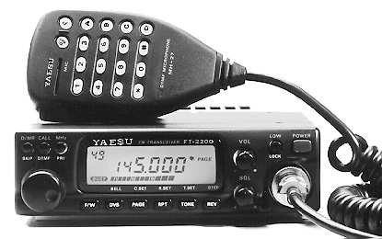

An example of a single band VHF radio from Yaesu – note the relatively few controls.

Probably the cheapest method (at one time anyway) to get a good quality mobile radio was to purchase a reprogrammed PMR* radio from the likes of Motorola, TAIT, Phillips etc. Not as common as they used to be, they do still make plenty of appearances at radio rallies and online auction sites. A lot of care needs to be exercised initially when considering a purchase to ensure that you are getting what you need!
Along with all the usual stuff about warranties etc. ask the crucial question (when buying any VHF/UHF radio for that matter) ‘does it have CTCSS onboard already?’ - if the answer is ‘no’ then remember it will not be any use to you trying to access the repeater network(s) - since 2005 all UK repeaters must use CTCSS for access!

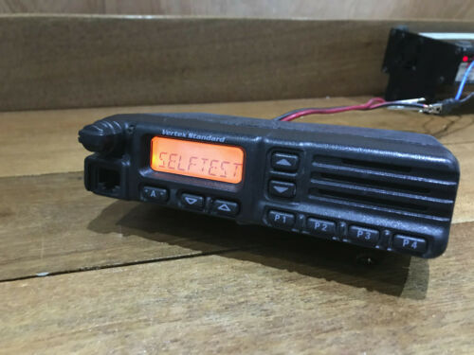
A Yaesu commercial PMR Radio.

Having ascertained that your prospective buy does indeed have the relevant CTCSS tones programmed in, make sure its complete. By the way, a lot of the commercial radio equipment uses a BNC type antenna connector, so make sure you buy an adaptor if necessary.

Repurposed PMR radios can be extremely good value for money, they cost a lot of money when new (several hundreds of pounds) and are built to very high standard! They come in a myriad of versions from a 4 channel Tait ex-taxi radio to a 200 channel Motorola unit from a Fire engine. Whatever you buy, expect good quality audio on both receive and transmit.

The seller will be able to advise you on power output – just make sure it stays within you licence terms and conditions, beside which you shouldn’t transmit more than about 10 watts to any repeater anyway, more than that just de-senses the receiver!

One of the most useful things to look for in a mobile radio is simplicity of use combined with very few controls. While there is a specific exemption in law that covers using an Amateur Radio while driving, we all know the dangers of being distracted while in control of a vehicle. Regardless of the above, the courts etc will take a very dim view of any operator involved in an accident, if there is the slightest hint that operating a mobile radio was a contributing factor! Keep your overs ‘short and sweet’ and stay in control at all times – consider fitting a hands-free kit if you operate mobile a lot!

*Note: When referring to repurposed PMR radio equipment for amateur radio use, we are not talking about the 8-channel licence free handheld radios available on the market as children's toys etc.

Power Supplies & SWR Meters

Generally handheld radio’s come these days with rechargeable batteries – please be very careful when disposing of them, although with care they will last a long time indeed.

Some base station units – usually more expensive items - plug in to the mains, with their own built in power supply units. Less expensive base stations and all mobile radios (being used as base units) require a power source.

One obvious method is to use a ‘car battery’ and a charger – a word from the wise ‘Don’t’! In simple terms, car batteries are not designed to be discharged over long periods, they are designed to produce short periods of high current (for cranking an engine over etc). The constant drain and recharging that an amateur radio station will put a battery under great strain, and it will quickly fail!*

It’s a different story altogether when it comes to the modern ‘leisure’ batteries designed for use in boats, camper van, caravans etc. These ARE designed to discharge over a longer period but remember they do need an ‘intelligent’ charger as well. The only major downside to running a station using a leisure battery is the high overall initial cost and the associated hazards of charging a battery inside.

The other obvious solution is to use a power supply regulated for the relevant power output – normally 13.8 Volts. Again, it’s entirely feasible to save a lot of money and build a power supply. It’s a relatively simple project but one that must be approached with some caution as you will be dealing with mains voltages i.e., 230 Volts. You are advised to seek the assistance of a knowledgeable member of the club when embarking on such an exercise. The other option is to buy one!

Cost depends on a number of things, but the better the quality and the higher the amperage the unit is able to supply, will specify its price. Modern switch mode PSU’s cost from approximately £25 to £100+, they benefit from being reasonably light weight and are fairly efficient, however they are prone to ‘making noise’ and can (and will) fail in the most spectacular way. The older ‘linear’ type PSU’s weigh (in comparison to a switch mode) a whole lot more but tend to be both stable and reasonably robust!

Approach a PSU of unknown heritage with both caution and care; if at all doubtful thoroughly test it BEFORE attaching anything valuable, like a radio, to it!
You only really want to buy a PSU once, so buy the best you can get and for general use in the shack it wants to be able to supply 25 -30 Amps minimum.

*NOTE – Powering a mobile radio from the battery in your car is far less of a problem, as the alternator will be feeding the demand when the engine is running! Just don’t spend a whole day Dxing from a portable location and end up with a flat battery……..

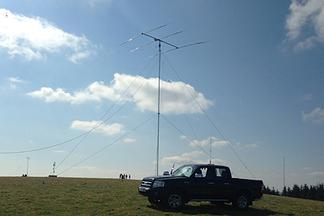

Voltage Standing Wave Ratio Meters (VSWR)

Your station VSWR meter is probably one of the most important pieces of equipment in you shack – it will give you a lot of information, once you learn to interpret what its reporting and when!

There are numerous different versions (like most things) and in this particular case it really does pay to buy the most expensive item you can afford right at the beginning of your amateur radio career.

An VSWR meter is a relatively simple mechanical device that relies on two match components (diodes) to work accurately – in simple terms the higher quality they are the better the unit will be! VSWR Meters come in many flavours, with a single needle meter, crossed needle meters, twin meters, electronic displays etc. They all work in pretty much the same way and display similar information:

Prices range from less than a tenner for a unit fit for Citizens Band radio, to one’s costing £100’s.
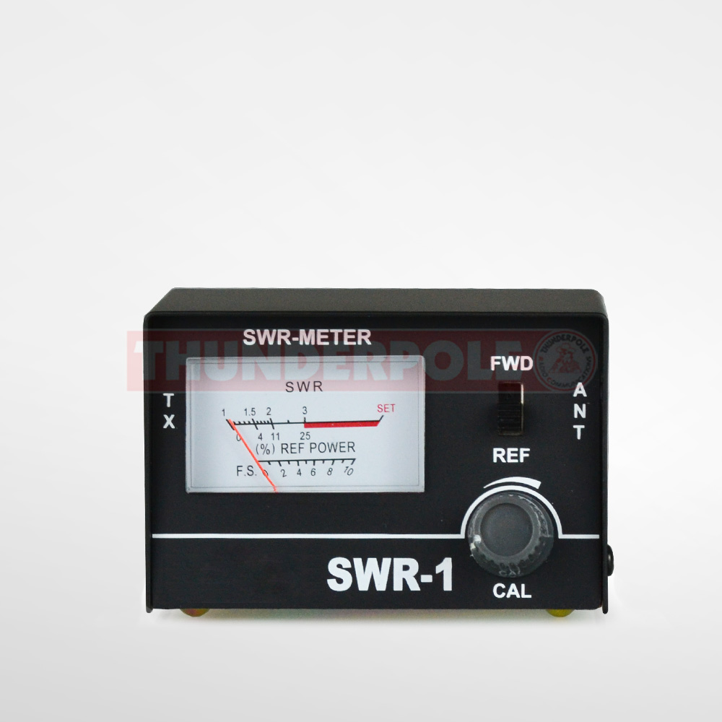
A ‘Ten pound special’, single meter, single feed unit.

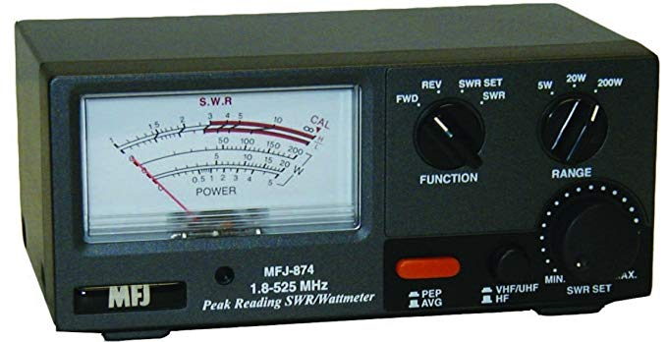

Something a little more useful – another
Single Meter, Single Needle unit from MFJ.

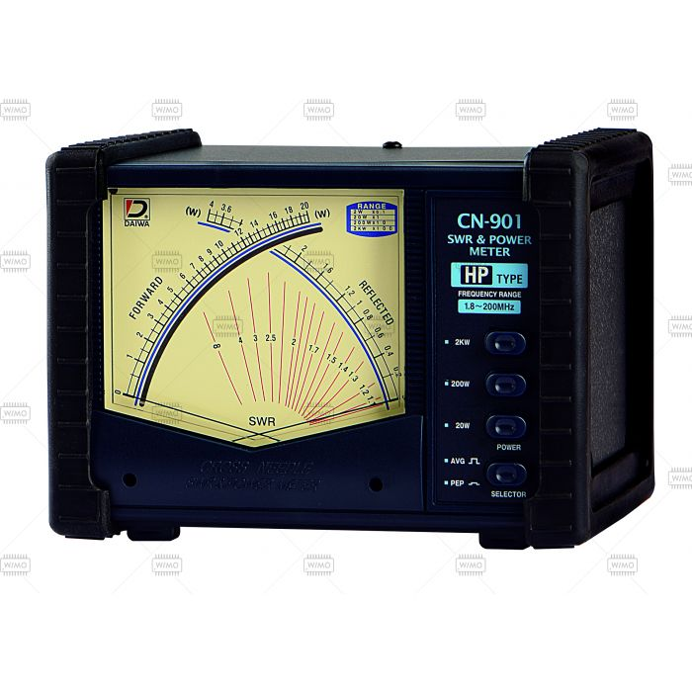
This is an example of a very nice crossed needle meter, capable of handling high power.

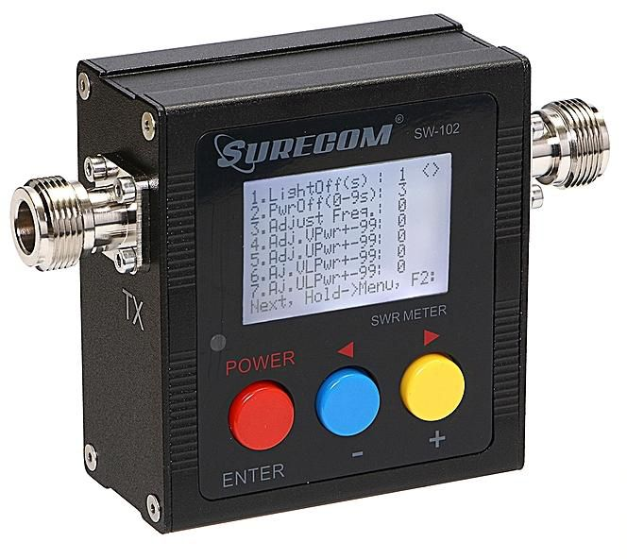

Keep in mind also that it’s unlikely that you will be able to find an VSWR meter that covers the HF and the VHF/UHF spectrum as well. However, unless you intend to experiment building antennas, a VHF/UHF meter is not an immediate necessity.

Whatever you get, buy the best you can afford, even if it means saving up a bit first – a quality VSWR meter will tell you if you have problems with your antenna a long time before your radio does! Just make sure you thoroughly read the instructions for the model you acquire – you will be shown how to use various VSWR meters correctly during your Foundation Licence course.

VHF Antennas

It won’t take you long to realise that installing a larger antenna at your shack location will improve both reception/transmission coverage. It’s true to say that (particularly at VHF/UHF) the higher your antennas are above ground level the further you will be able to transmit and receive. Every knowledgeable operator would willingly trade ‘antenna height’ over ‘radiated power’ any day of the week!

The first thing you need to consider is permission to install – do you need to seek local planning permission, local government (parish, borough, town etc). You need to ask around; a lot of new build sites have legal restrictions on the erection of TV and Satellite dishes and will have clauses covering ‘Amateur Radio’ antennas too. Club members will also have a very good idea of local planning rules and regulations.

Next you need to decide what sort of antenna you want to install; a lot of that choice is dictated by the actual final position of the antenna itself. Obviously, trying to put a 4m high vertical antenna in your loft is a nonstarter (unless you live in a church…) - Such a piece of equipment realistically needs to be erected outside, using the supplied brackets etc.

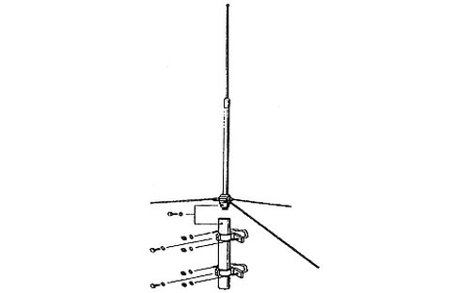

A typical dual band vertical antenna exterior installation. Used mainly for FM simplex and repeater access.

Incidentally, most commercial VHF/UHF antennas come pre-tuned from the manufacturer and are unlikely to need more than an initial check during installation.

What happens if you can’t install an antenna on the roof or exterior of your property?? All is not lost by any shakes; you just have to accept some compromises and work a little harder to achieve your aims.

Fortunately, its possible to install a relatively high gain VHF or UHF (or dual bander) in a reasonably small space, like a modern town house attic.

A ‘Slim Jim’
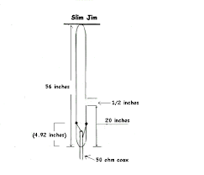
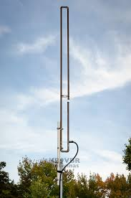

Two examples of a type of antenna that lends itself to indoor installation and being built (or brewed) at home.

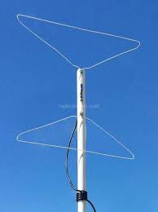
Other examples of indoor installations include:

The ‘coat hanger special’.

Made very simply and quickly, using metal coat hangers, plastic conduit and some RG58 coax. A firm favourite, it will also exhibit some directional qualities, which can be useful.

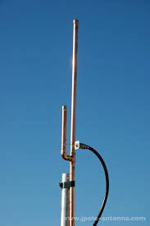

A ‘J pole’ Antenna. Another example of great antenna that can be home brewed – this is a UHF (70Cm Band) version. The TARS website has downloadable plans for an easy to build dual band version.

A ‘Halo’ antenna, a great antenna to install in a loft space – easy to build and very cost effective.

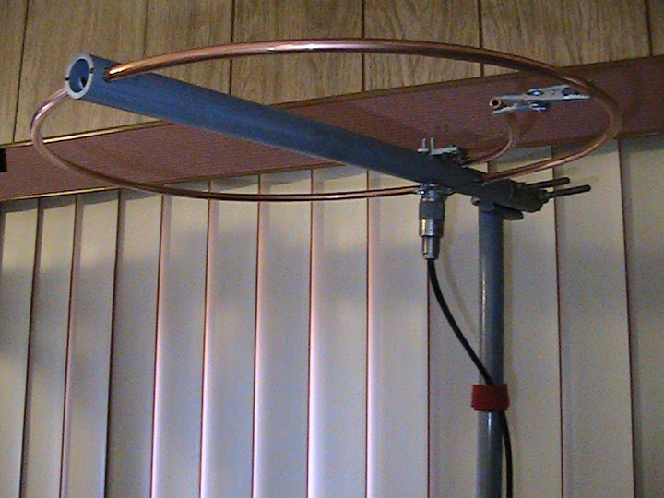

You may eventually decide to invest in something much larger and more comprehensive, our advice is to keep it simple, at least initially!
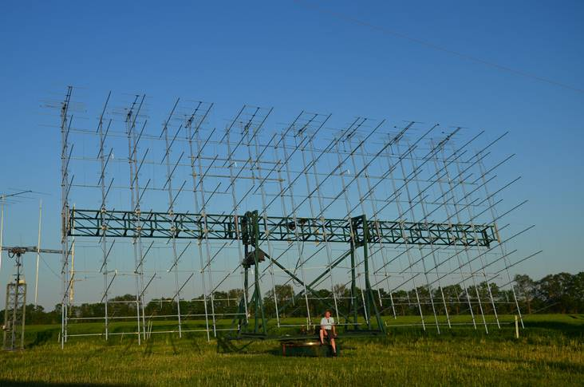
Antenna Installations & Safety

Having decided which antenna you want – there are literally hundreds to choose from – the next task is to install it.

Please read and follow all the advice given here – it might just save your life!

Young people in particular need careful supervision due to their poor risk assessing abilities. They should never, under any circumstances be left unsupervised during the installation or removal of antennas, or any other equipment for that matter.

Keep in mind that it is highly dangerous to try an install antenna near or underneath electrical power lines – the voltages & current carried will leap across gaps to earth, with catastrophic results;

Go and find another site!

- 1. If you are installing an antenna installation for the first time, for your own safety and others seek help and advice.

- 2. Choose where you are going to install the antenna(s) with care; electrical power lines and telephone lines look the same – assume they will kill you!

- 3. Read all instructions first, before you start work, identify all parts and make sure that fittings and connections all work – pre-fit coax connectors.

- 4. Don’t attempt an installation if the weather is poor, especially if its windy. Wear proper clothing and use safety equipment as necessary. Avoid working on your own, if at all possible, when using a ladder or when working at height. Always tell someone, whom you can rely on, what you are doing and ask them to check on you periodically.

- 5. If an installation begins to fall, let it drop! It’s surprising how little weight (mass) is required to pull somebody off a ladder it they are already in a compromised position! Even the slightest contact between a mast/antenna and a power line will result in a short to earth – via you!! Let it drop, no antenna is worth your life!
- If any part of your antenna installation should come into contact with a power line – LEAVE IT ALONE – Call the power company who will come and remove it safely.

- In the event of an accident involving power lines/mains, do not touch the casualty until 100% sure that they are no longer in danger of electrocuting a would be first aider! Send someone to alert the emergency services immediately.

- It is always worth considering employing the services of a professional installer. Ring or ask around and try to find one who is familiar with the needs of Amateur Radio operators, which do differ from ordinary TV aerial & satellite dish installs. At the very least they will be able to offer you good advice about where not to put things!

- When planning an installation, try as far as possible to ensure that in the event of the pole/mast/antenna coming down in an uncontrolled manner (for whatever reason) that it avoids power lines and neighbours’ property. Don’t forget to add the length of an antenna to the length of the pole or mast when calculating final lengths.

- If there really is any possibility of any of your equipment coming to rest in or on someone else's property, they you really should have insurance to cover any damages that may be incurred in the event of an accident. The RSGB are able to advise members on this matter.

DISCLAIMER:

IMPORTANT NOTE - The advice offered here is generic, it is up to individuals to ensure that they take the utmost care to ensure that both they, and anyone else in the area which you are working remain safe. Activities carried out within the public domain will need a risk assessment to be carried out for Health & Safety purposes, the relevant safety equipment should be supplied and used, and the correct indemnity insurance cover held.

For further advice on installing antennas etc. search the RSGB Website and that of the UK Gov’s Health and Safety Executive etc.
Coax Cable & Associated Connectors

Mentioned earlier in this guide, coax and connectors are a fundamental part of your radio station, without them it’s not particularly easy to get the signal generated by your transceiver up to the antenna and then out into the ether.

During your Foundation course you should’ve been introduced to the ‘art’ of fitting connector plugs to coax cables. Cables come in different lengths & sizes, the one’s you use to connect your rig to your VSWR meter and AMU are generally referred to as ‘patch leads’, longer lengths are known as ‘feed’ or ‘feeder’ lines. Not all feed lines are coaxial, you can use ‘twin wire’ feeder as well, however caution should be exercised when using this medium due to its varying impedances and susceptibility to interference from localised metal items – i.e. metal masts, guttering, metal roofs etc.

Words of Wisdom: Feeder lines can pose quite a trip hazard when laid on the floor, especially as they have a habit of coiling up! Equally, they should be placed well above head height to avoid a choking hazard – this maybe more of an issue at temporary installations or field stations and as such should be included in the relevant risk assessment. Where lines lay on the floor etc they should be clearly marked with hazard tape and highlighted to all.

Connector plugs come in a vast array of different types; most were designed for a specific task.

The PL259 Plug connector (and is accompanying SO239 socket) have been around since the 1940’s and are also known as ‘UHF connectors’ – although their properties at that frequency range are questionable.

‘N’ Type connectors are from a later era and are far more suitable for VHF and above installations, due to the lower losses.

BNC connectors were developed with the commercial sector in mind again with better performance at higher frequencies.

SMA Connectors are a recent introduction to the Amateur Radio world, a link over from the Military/Computer worlds.

It should be fairly clear by now that connectors play a very important part in your station, and it’s very much a false economy to buy dirt cheap one’s – ask a member of the training team for information on what to look for and what not to buy!
You should refer to the relevant chapter of the current Foundation Licence Manual for further information and diagrams of the above plugs. Virtually every single member of the hobby has their own method of fitting connectors – some prefer to use crimp on plugs, preparation for use is broadly similar but without the necessity of soldering. The simplicity of use is offset by the high cost of the tools required to crimp all the different plugs onto the various types of feeder line.

Obviously, soldering plugs/connectors on requires a soldering iron but not much more and again the preparation required is similar to that for crimping. A good quality soldering iron really is one of those tools that every operator should aspire to acquire and it’s likely that you will end up with more than one! Trying to solder a PL259 connector on the end of a very long length of Westflex 103 coax with a 15 watt iron is a waste of time!

Not only will the Trg Tm demonstrate their preferred methods of fitting plugs and connectors, you will find a lot of information & demonstrations on ‘Youtube’ and other Amateur Radio related sites, guides are also published in the RSGB Year Book and other technical journals. We suggest you decide for yourself, which is your preferred method and practice it, remembering to test you newly constructed leads (long or short) using a VOM meter, set to ‘Continuity Test’.

Operating Your Station

UK Call Signs – Current Allocations (@ 2019)

Licensee | Prefix | Secondary Id
Full | G*: 0 to 8 | W,I,M,U,J,D.
 | M 0,1,5
Intermediate | 2#0 & 2#1 | E,W,M,U,J,D.
Foundation | M3, 6 & 7 | W,I,M,U,J,D.
Club/Special | GX, MX, GB | As Req.

* Note: In mid-2019 the RSGB allowed full licence holders to apply for unallocated short ‘G’ call signs i.e. G0AB etc.

Signal (RST) Reports

One of the pieces of information that makes up a ‘bare bones’ contact or ‘QSO’ is the ‘Signal’ or ‘RST’ report, which are given as a numerical factor.

‘R’ stands for ‘readability’.
‘S’ stands for ‘signal strength’ (according to your radio’s meter).
‘T’ stands for ‘tone’ and is used predominantly by Morse operators only.

The ‘Readability’ of a signal is graded from 1 – 5 (One to Five).

One | Unreadable
Two | Barely readable, some words distinguishable
Three | Readable with considerable difficulty
Four | Readable with little difficulty
Five | Perfectly readable, no difficulties

The Signal strength is graded from 1 – 9 (One to Nine).

One | Faint Signals, barely perceptible
Two | Very weak signal
Three | Weak signal
Four | Fair signal
Five | Fairly good signal
Six | Good Signal
Seven | Moderately Strong Signal
Eight | Strong Signal
Nine | Extremely Strong Signal

Signals vary considerably for any number of reasons, signals that appear to ‘fade’ in and out on a regular cycle are said to be subject to ‘QSB*’.

Signals subject to static or noise possible of a man-made nature are referred to as having ‘QRM*’

Signals subject to interference - deliberate or otherwise – are referred to as having ‘QRM*’

*Note: See the attached listing for details of ‘Q Code’ abbreviations.

The NATO Phonetic Alphabet

A | ALPHA | N | NOVEMBER
B | BRAVO | O | OSCAR
C | CHARLIE | P | PAPA
D | DELTA | Q | QUEBEC
E | ECHO | R | ROMEO
F | FOXTROT | S | SIERRA
G | GOLF | T | TANGO
H | HOTEL | U | UNIFORM
I | INDIA | V | VICTOR
J | JULIET | W | WHISKY
K | KILO | X | X-RAY
L | LIMA | Y | YANKEE
M | MIKE | Z | ZULU

Q CODES

QRZ? QRZ? QRM PSE QSY UP 5K

Roughly translated this means:
‘Who is calling me? Who is calling me?’

There is interference on this frequency.

Please change frequency and go up by 5 KHz.

Q codes and abbreviations are very useful when communicating under difficult conditions, when there is adjacent interference or with someone who is not fluent in English. Q codes also save time; it is quicker to send ‘QRM’ than ‘I am getting interference from other stations’.

EXAMPLE:

GU0SUP DE M5AEX ALL COPIED PHIL. YOU ARE A STRONG SIGNAL HERE. YOUR REPORT 59 59. WEATHER HERE IS OVERCAST. ITS COLD AND RAINING AND ABOUT 12 DEGREES CENTIGRADE. EQUIPMENT HERE IS AN ICOM IC756 PRO. I’M RUNNING 100 WATTS INTO A DIPOLE AT 10 METRES ABOVE GROUND LEVEL. CONDITIONS AREN'T GOOD. THERE IS SOME QRM AND ALSO QSB ON YOUR SIGNAL. ANYWAY, THANKS FOR THE SHORT QSO. 73’S GU0SUP DE M5AEX

Q codes are not just confined to amateur radio. Q codes cover general communications as well as maritime and aeronautical communications and provide an internationally accepted method of exchanging a great deal of information with a simple abbreviated code.

The Q Code consists of three-letter groups with each group having a specific meaning. Each group begins with the letter Q! The second letter tends to indicate the service for which it is intended and the third the message itself.

Q code abbreviations can be given as a statement or asked as a question with the addition of a question mark.

For example, ‘QRN’ means ‘I am troubled by static’ and ‘QRN?’ means ‘Are you troubled by static?’

Although the Q codes have a formal definition, they also tend to have a colloquial meaning to.
Typical Q codes used by radio amateurs are as follows:

Q CODE | STATEMENT | QUESTION
QRM | There is interference (man-made) | Are you being interfered?
QRN | I am being troubled by atmospheric noise (static) | Are you being troubled by atmospheric noise (static)?
QRO | Increase power (but also used as ‘I am running high power’) | Shall I increase power?
QRP | Decrease power (but also used as ‘I am running low power’) | Shall I decrease power?
QRT | Stop sending (also means ‘I am closing the station down’) | Shall I stop sending?
QRV | I am ready | Are you ready?
QRX | I will call you again at (time)* | Will you call me again at (time)
QRZ | You are being called by… | Who is calling me?
QSB | Your signals are fading | Are my signals fading?
QSL | I am acknowledging receipt *1. | Can you acknowledge receipt?
QSO | I can communicate with…*2. | Can you communicate with…?
QSY | Transmit on another frequency | Shall I transmit on another frequency?
QTH | My position is…*3. | What is your position?

*(also used to indicate a pause – QRX 1 can mean ‘wait one minute’)

1.(i.e. I confirm that I have received the information you sent me)

2.(also used to indicate a ‘contact’ – M5AEX today)

3. (also used to refer to the location of one’s shack – ‘My QTH is in Bedford…’)

All of the above Q codes would be used for exchanges in CW, RTTY and Phone.

There are additional codes for CW, such as QRS – ‘please send more slowly’.
Logging contacts – Keeping a logbook

Keeping a logbook is part of the hobby, while there is no longer a legal requirement to keep a logbook it’s wise to do so! How else are you going to keep a record of whom you have spoken to last week, last month or last year? How else are you going to record whether you’ve received a reply to the QSL cards you sent out via the RSGB Bureau some months ago? What other evidence can you produce to a representative of OfCom who is carrying out an investigation into an interference claim in your locality?

There are many good reasons to keep a log, not least of which for the sheer pleasure of doing so! A well-kept, neat and organised log book can become a prized possession in the shack, a talking point and source of pride.

So, what sort of information should you record in a logbook? To save you the effort of making your own (which you can do if you so wish) logbooks are available commercially from numerous outlets, in various sizes. Generically, they tend to be spiral bound A4 portrait soft back books, with loose leaf pages.

Computerised logging has become very popular, with quite a few different programmes available. They have been developed over the years for radically varied reasons. Some are specifically aimed at operators who want to take part in contests, others for those who want to chase awards. Others are highly integrated with real time, online updating that fully automate some parts of a shack (like sending out Electronic QSL Cards – EQSL).

Whichever method you chose to use, and if using a computer we highly recommend some form of automated back-up, loosing years of stored QSO data is probably any operators worst nightmare!

Completing an entry in a logbook is a fairly straight forward task, just remember that all timings are entered in ‘UTC Time’ - ‘Universal Time Coordinated’ to give it its full title.

What is meant by UTC time?

Prior to 1972, this time was referred to as Greenwich Mean Time (GMT) but is now referred to as ‘Coordinated Universal Time or Universal Time Coordinated’. It is a coordinated time scale maintained by the Bureau International des Poinds et Mesures (BIPM).
In real terms, all you need to remember is to take into account the hour difference when the clocks in UK change to BST (British Summer Time).

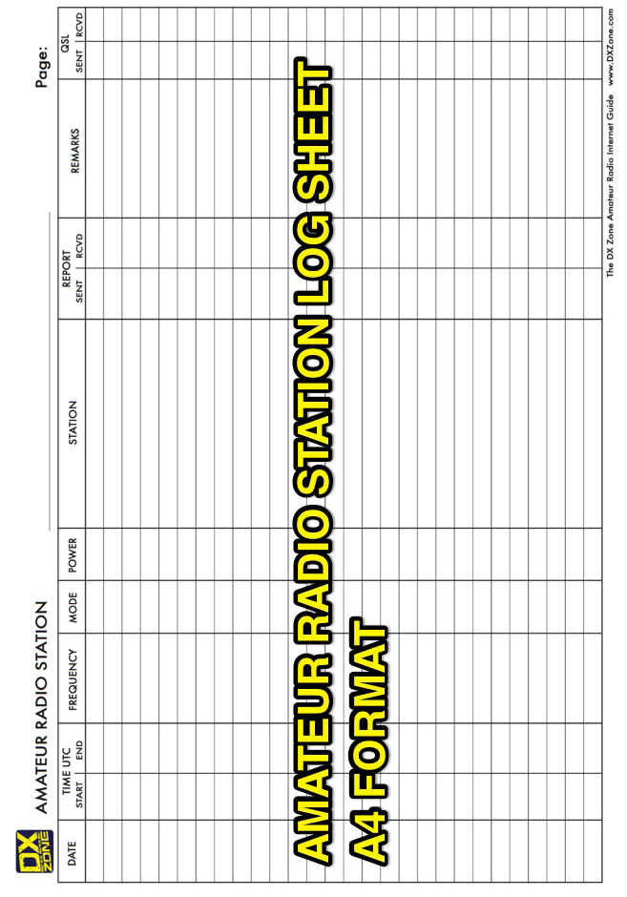
Your First Contact

In some respects, gaining an Amateur Radio Licence is a bit like getting your driving licence; you only really start to learn once you have passed your test and are totally on your own – the one in charge!

To help you through this occasion, which for some people despite their desire to communicate, can be a daunting prospect – it shouldn’t be, so we’ve compiled this brief guide.

Hopefully, you will have been given plenty of opportunity to practice during your Foundation Licence course, we’ve also included some guidance and examples of sample contacts (QSO’s) here in this guide, so you aren’t entirely at a loss as what to say initially.

COMMON CALL SCRIPTS

The following are suggestions only, on the type of initial transmissions you can make to initiate a call over the amateur radio allocation of frequencies, repeaters and Nets.

With growing experience and confidence operators go on to develop their own distinctive ‘style’. (note this brief does not cover Morse or Data Modes etc.)

1. Making a ‘general call’ for contacts, using HF/VHF/UHF telephony.

Note: VHF/UHF allocations normally have accepted ‘calling channels’ - see band plans for details.

‘Is this frequency in use please (pause & listen)?
‘Is this frequency in use please (pause & listen)?

‘Hello CQ, Hello CQ, Hello CQ this is M6ABC Calling CQ , Calling CQ, standing by and listening.
‘Hello CQ, Hello CQ, Hello CQ this is M6ABC Calling CQ, Calling CQ, standing by and listening.
‘Hello CQ, Hello CQ, Hello CQ this is M6ABC Calling CQ, Calling CQ, standing by and listening, Over.

Possible response:

M6ABC this M0XYZ, a very good afternoon to you. You are good clear signal with me this afternoon, I’m reading you at 5 by 9+(five by nine plus). Operator name is ‘Lin’ – I spell for you Lima, India, November and my QTH is the City of Exeter in the South West of UK, Over.

Suggested Reply:

M0XYZ from M6ABC, all received old man, you are also a good signal, I’m reading you at 5 by 8 (five by eight). My operator name is _________ and my current QTH is _______________. Over

(The above is the bare minimum accepted for the sending of a QSL card or to be regarded as a legitimate contact for contesting purposes)

The conversation could then move onto a weather report (WX) and details of equipment being used.

This is also about as much info as you can expect from an operator for whom English is NOT their first language. It is for this reason as much as any, that the use of ‘slang and nonstandard abbreviations or codes’ are frowned upon! (Remember what your T&C’s say??)

You do not have a ‘personal’; you have an operator name!
You have a QTH (home/current location) not a ‘home 20’!
It is acceptable (if only to other operators) to refer to you wife/partner as an ‘XYL’…

2. MAKING A CALL VIA A REPEATER

Repeaters are primarily for the use of mobile stations, its good operating practice and plain courtesy to relinquish the use of a repeater for a mobile or portable station to use. Also remember that this region is a tourist destination, so on occasion you will encounter nonlocal users! Demonstrate good operating practice and lead by example. All repeaters are viewed as unmanned stations and must transmit their call signs at least every fifteen minutes – normally this is done in Morse Code, but some will also have recorded voice messages as well.

Tune up on the relevant frequency and listen, if the repeater is clear then feel free to put a call through. (See repeater listings on the RSGB website)

‘This is M6ABC/P listening through’ (TR, EX, EW etc. or GB3DR etc.). Over.

The repeater will, if your radio is set up correctly (CTCSS tone*, shift etc.) open up and you will hear an acknowledgement tone upon releasing the Push To Talk button (PTT).

If you don’t get a response, you can of course try again:

‘This is M6ABC /P listening through’ (TR, EX, EW etc. or GB3DR etc.). Over.

Possible response:

M6ABC/P this M0XYZ/M good afternoon to you. You are fully quieting into the repeater but have a slight amount of scratchiness over your transmission – a readable radio 4 (four). Over.

Suggested Reply:

M0XYZ/M from M6ABC/P, thanks for coming back to my call and the radio report, Your perfectly readable with no problems. Over

M6ABC /P this M0XYZ/M, Thanks for the report, my name is Lin and I’m currently mobile heading down to Newton Abbot for a club meeting at the Scout HQ. Over

M0XYZ/M from M6ABC/P. Roger on all of that Lin, my name is ___________ and I’m pedestrian mobile in Newton Abbot, sounds like were heading for the same location! I have a brew ready for you on arrival! Over. ETC. ETC.

Initiating a Frequency Change

It is also good practice to switch to (QSY) a ‘simplex’ frequency if you can make contact with the other station – particularly if you want to have a ‘rag chew’ across town…..

Possible Message:

M6ABC /P this M0XYZ/M, I’ve been listing to the (repeater) input (frequency) and I can hear you as a 5 by 6, can you switch to simplex please? Over.

Suggested Response:

M0XYZ/M from M6ABC/P copy your last and will QSY to 145.425 (One four five decimal four two five) repeat will QSY to 145.425. Over.

Reply:

M6ABC /P this M0XYZ/M confirmed, QSY to 145.425. OUT.

Having retuned to 145.425:

M6ABC/P this M0XYZ/M, standing by and listening for you. Over.

The QSO can then carry on as the operators wish.

3. Joining a QSO or Net

Joining an established Net is simply a question of good timing (esp. on a repeater), however a good net controller will always call regularly, for waiting operators to sign in and join the net, esp. during the first ten to twenty minutes of opening a net.

Joining in later on can be a little more difficult, but with the speedy use of the word ‘Break’, it can be achieved. Whether you get an acknowledgement or response is entirely up to those involved……. Do NOT use ‘BREAK, BREAK’ to join a QSO/NET unless you have EMERGENCY traffic to pass!

Remember: When joining a net/QSO give your call sign & name, greet other operators, thank Net Control for bringing you in and when you have made your over, unless otherwise directed, return to Net Control with something like:

‘M6ABC in the group, returning to Net Control over’

*See Annex A to this document regarding an explanation of ‘CTCSS’

BRIEF QSO SCRIPT FOR PRACTICAL ASSESSMENTS

Having contacted another station what do you say or talk about??

Example (insert your information as necessary) :

1. (M0ABC) this (M6XYZ), a very good afternoon to you, thank you for answering my call.

My QTH is ……………..., which is located in the South West of the United Kingdom and my

operator name is …………………………………… …………….(spell phonetically).

Your radio and signal report is ……………………………… by ……………………………………...

I am currently using a (rig)..…..…..…………… which is feeding (antenna)………………………….

I am only transmitting using a maximum power of 10 watts.

The weather at my location is:………………………………………………………………………OVER

2. Please can I have your QTH, a signal report, details of your equipment, power output & weather report. OVER

3. Thank you for all that information, I have it in my logbook (and will EQSL/QSL as appropriate). OVER

4. I wish you 73’s, good DX for the rest of the day, all the best to you and your family. Catch you further down the log. OVER

5. (M6XYZ) now signing clear from (M0ABC) 73. OUT

The above is roughly what is accepted as a basic QSO – obviously, you would complete the relevant details in you logbook such as date, time, frequency, signal reports, QSL’s, WX reports etc.

Reminder: OVER – an invitation to respond.

OUT – Completion of contact, no further response expected.
Retailers, Books & Further Useful Information

People – Useful Contacts:
RSGB Regional Volunteer:

Club President:

Club Chairman:

Club Membership Secretary:

Training Team Manager:

Radio:

GB2RS News Broadcast – RSGB Website for details.
Reverse Beacon Network

Books & Magazines:

RSGB Website
Internet Auction Sites
Rallies

Useful/Recommended Internet Sites:

www.rsgb.org.uk
www.tars.org.uk
www.youtube.com soldering skills, fitting PL259’s etc, antenna construction etc.

SW Clubs
Torbay Amateur Radio Society: www.tars.org.uk
Rivera Amateur Radio Club: www.rivieraarc.org.uk
Exeter Amateur Radio Society: www.exeterars.org.uk
Tiverton South West Amateur Radio Club: www.facebook.com/G4TSW
Sidmouth Amateur Radio Club: www.sidmouthars.org.uk
Plymouth Amateur Radio Club: www.plymouthamateurradioclub.btck.co.uk
Saltash & District Amateur Radio Club: www.sadarc.co.uk
South Dorset Repeater Group: www.sdrg.co.uk

Other Useful Websites: FAQ’s About Amateur Radio asked by family, friends & Neighbours.
http://strugl.org/frequently-asked-questions-about-amateur-radio-stations-for-neighbours-and-communities/

Annex A.
Continuous Sub Audible Tones (CTCSS).

CTCSS tones are as their name describes, sub-audible tones that your radio transmits to a repeater in order to keep the repeater ‘open’ and working, while you press the PTT button. The relevant technology has been around for a while now and from 2004 Ofcom & the RSGB required all new repeaters coming on air to have the technology built in as standard, replacing the old 1750hz tone burst system.

With the greater proliferation of repeaters around the country and the effects of propagation, it was becoming more and more common for a user to open one local repeater and find himself linked to two or more at the same time, which was illegal and remains so today.

By programming adjacent repeaters with different CTCSS access tones and by the use of varied input/out frequencies, the problems of accidentally ‘daisy chaining’ repeaters together are greatly reduced.

Here in the UK we only use a limited number of the available tones:
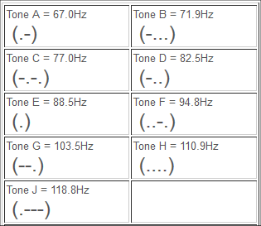

The last tone sent by a repeater, whilst identifying itself, will be its access tone (in Morse) I.E. GB3EW (2m repeater in Exeter) sends the letter ‘C’ indicating that its access tone is 77.0Hz. GB3TR sends an ‘F’ indicating an access tone of 94.8Hz.

A lot of the older VHF/UHF radios didn’t originally have CTCSS onboard as standard, for some it came as an (expensive) optional extra, others didn’t even have the facility to have it added. However, it’s not uncommon to find that radios, especially those that cost a lot initially or held favour with an owner, have been modified with the addition of a programmable CTCSS board! However, a new operator needs to keep his/her wits about themselves as these bargain radio’s might not be all that they seem – if you have the slightest doubt about the usefulness of a radio, ask someone! Don’t get overawed by the ‘bells, whistles and buttons’, you might be buying a shack door stop!

Virtually all modern radio’s, esp. at VHF & UHF (but increasingly HF as well) contain the relevant technology, that once set, will allow access to any repeater. Be aware that when setting radio’s for repeater access, that it is your radio only needs to ‘send’ out a CTCSS tone, it does not need to receive one back from the repeater – so make sure this function is not activated during set-up!

Care should also be taken not to mix up Digitally Code Squelch (DCS) with CTCSS – DCS is NOT used here in the UK on a day to day basis.
Annex B
Examples of Band Plans (2m & 6M)

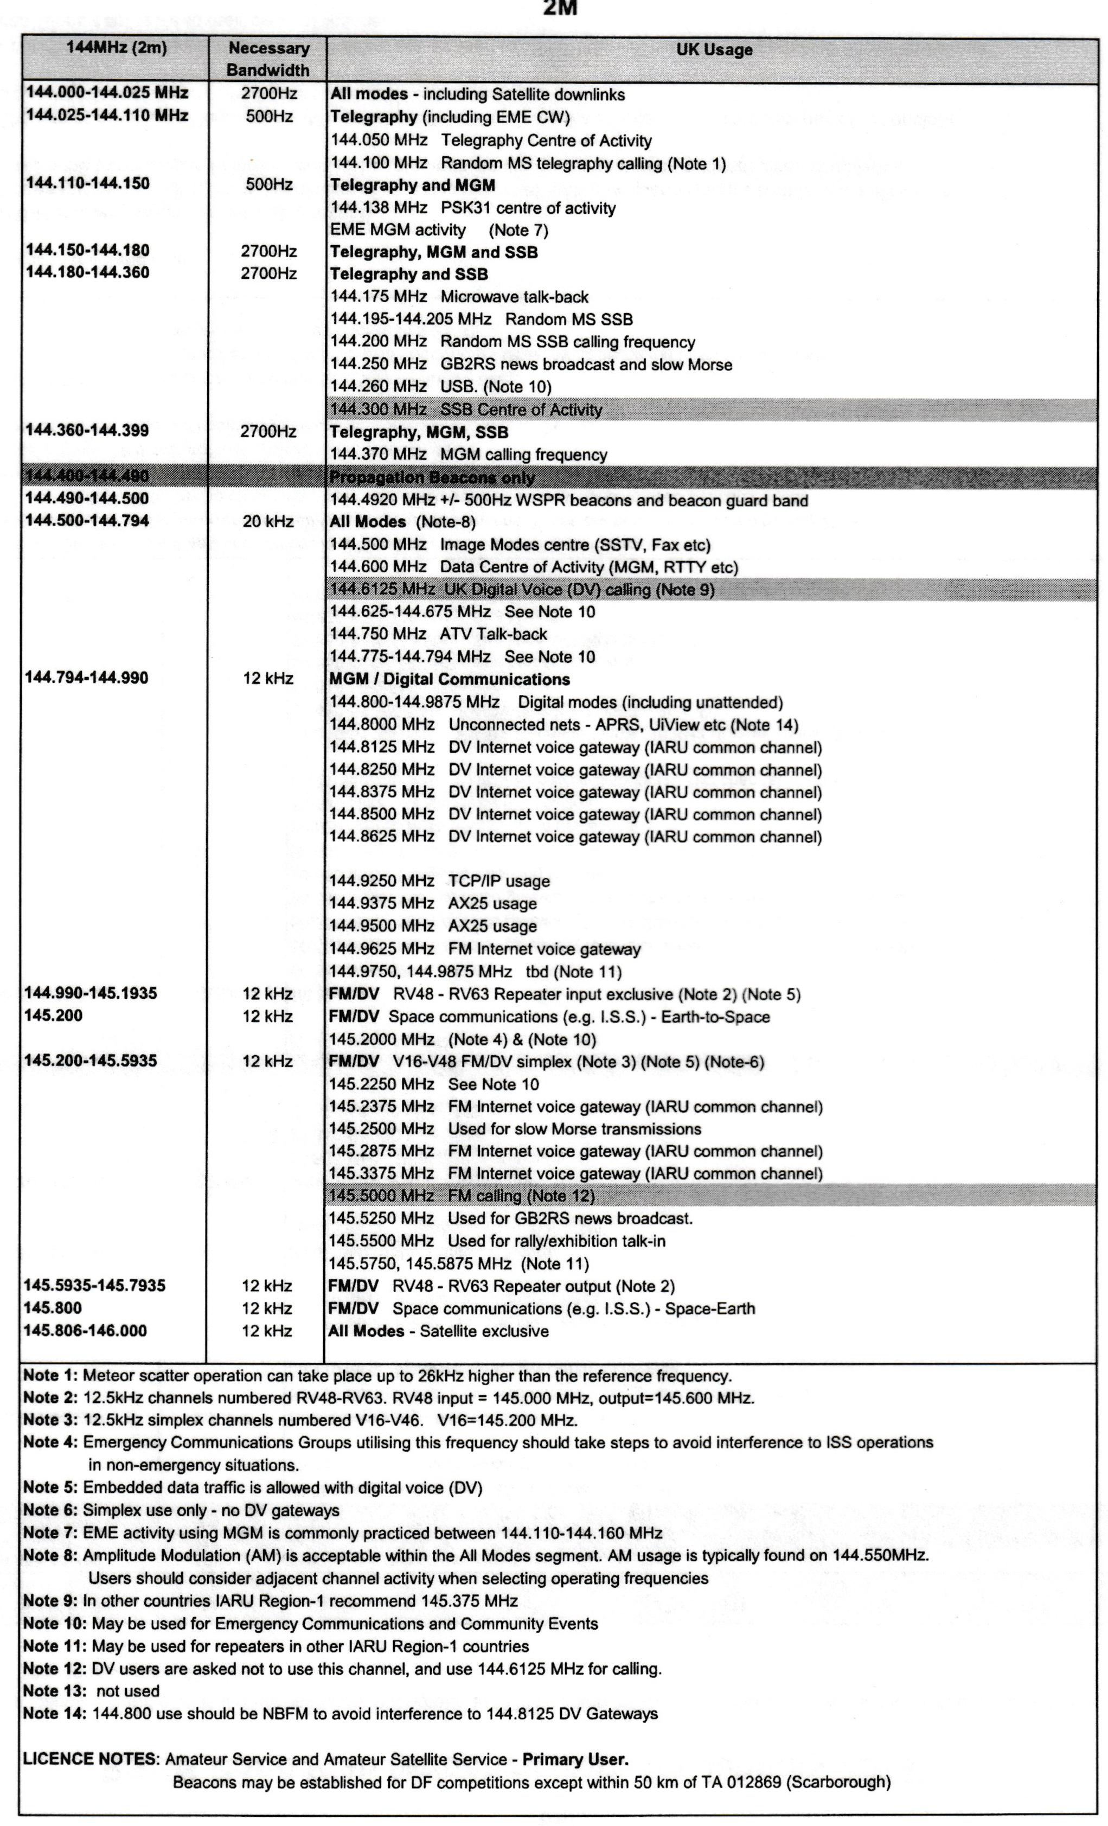
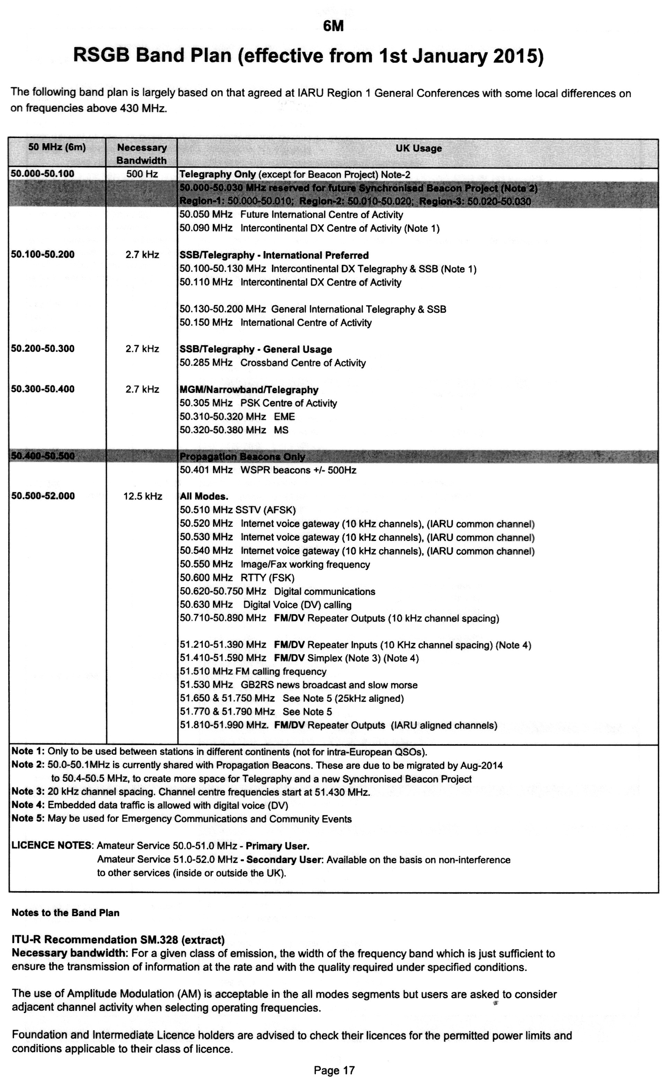
Annex C
Frequency Conversion Chart

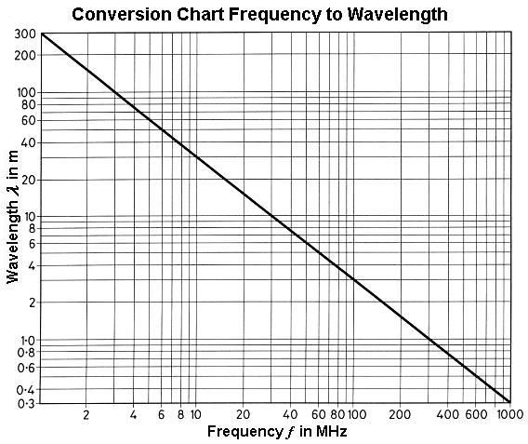

Annex D
South West Repeater List (2m & 70Cms)
South West Repeaters (50miles of Exeter) 2 Meters
C/S | RX | Shift | TX | CTCSS | Notes 50mls
GB3EW | 145.61250 | -0.6 | 145.01250 | 77 | Exeter
GB3SW | 145.71250 | -0.6 | 145.11250 | 77 | Sidmouth
GB3TR | 145.65000 | -0.6 | 145.05000 | 94.8 | Torquay
GB3PL | 145.76250 | -0.6 | 145.16250 | 77 | Plymouth
GB3WD | 145.70000 | -0.6 | 145.10000 | 77 | Plymouth
GB3DN | 145.63750 | -0.6 | 145.03750 | 77 | Stibbs Cross
GB3JC | 145.78750 | -0.6 | 145.18750 | 77 | Liskeard
GB3DR | 145.73750 | -0.6 | 145.13750 | 71.9 | Dorchester
GB3WE | 145.68750 | -0.6 | 145.08750 | 94.8 | WSM

South West Repeaters (50miles of Exeter) 70 cm Band
C/S | RX | Shift | TX | CTCSS | Notes 50mls
GB3EX | 430.95000 | +7.6 | 438.55000 | 77 | Silverton
GB7TQ | 430.88750 | +7.6 | 438.48750 | 94.8 | Torquay
GB3RH | 433.27500 | +1.6 | 434.87500 | 94.8 | Axminster
GB3VS | 433.07500 | +1.6 | 43467500 | 94.8 | Taunton
GB3IE | 430.85000 | +7.6 | 438.45000 | 77 | Plymouth
GB3ND | 433.35000 | +1.6 | 434.95000 | 77 | Bideford
GB3YS | 433.05000 | +1.6 | 434.65000 | 77 | Yeovil
GB3CH | 433.05000 | +1.6 | 434.65000 | 77 | Liskeard
GB3SD | 433.35000 | +1.6 | 434.95000 | 71.9 | Weymouth
GB3WB | 433.30000 | +1.6 | 434.90000 | 94.8 | WSM

Annex E
DX Code of Conduct

Intentionally Blank

